**YOUR LAST EMAIL WILL LOOK LIKE THIS**:

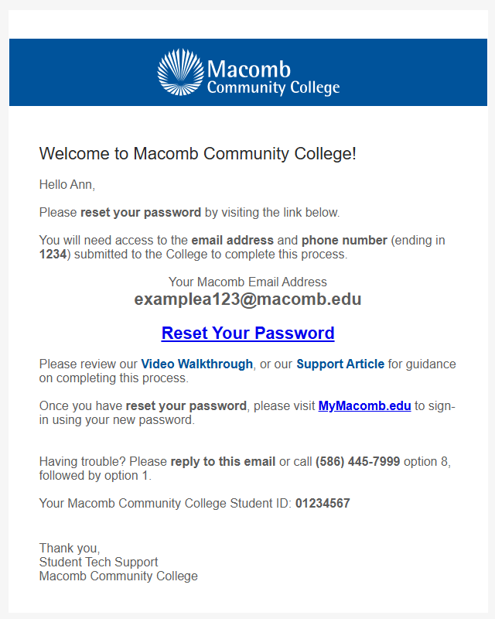

**AFTER YOUR MY MACOMB STUDENT PORTAL IS CREATED YOU CAN REGISTER FOR COURSES**:

Log  into your “My Macomb Student Portal ” and click on “SELF SERVICE” at the top of the page

then follow the directions below:

**Here is a link with an instructional video that may be helpful:** <https://macomb.hosted.panopto.com/Panopto/Pages/Viewer.aspx?id=f30f3181-8e90-4673-a251-b2aa00f0964d>